Digital Image Processing Techniques for Character Recognition

Kriti Tanwani

Department of Computer Science & Engineering

Jaipur Engineering College and Research Center

Sitapura, Tonk Road, Jaipur.

**Abstract**

The Digital Image Processing Techniques have been deployed in various areas including feature extraction and obtaining patterns of digital images. Character Recognition is a new problem. Although, presently there are many image processing algorithms that can identify characters from images, selection of appropriate techniques that can directly acclimatize to different types of images. This paper presents an overview of digital image processing techniques such as image enhancements, image restoration, and feature extraction, and focuses at presenting an acceptable image processing method for recognition of characters in digital images.

**Keywords**

*Character recognition, digital image processing, image processing, thresholding, morphological thinning, Hough transform*

**Introduction**

Image Processing has been under great development with the advancement of science and technology. An image can be digitized to transform it into computer memory storable or other forms of media storage such as CD-ROM or hard disk. Digital image processing lays emphasis on two main tasks: amelioration of

pictorial information for the purpose of human interpretation and data image processing for storage, representation, and transmission for independent machine perception.

Digital image processing often engage many procedures such as formatting the data, digital enhancement for improved visual interpretation, and automated target classifications and features by computer.

There are various techniques that have been part of the digital image processing methods. Preprocessing of Images, Image Enhancement, Transformation of Images and Image Classification & Analysis are a number of image processing methods available in image analysis.

**Preprocessing** involves the operations that are required before main analysis of data and information extraction and are broadly categorized as geometric or radiometric corrections. Radiometric corrections involve correction of data for sensor irregularities and atmospheric noise, as well as converting the data so that they precisely represent the reflected radiation which is measured by the sensor. Geometric corrections include amending the geometric distortions because of sensor-earth geometry variations, and rebirth of data to actual world coordinates such as latitude and longitude and on the surface of earth.

**Image Enhancement** involves modification of one or more components of image to increase clarity and details through visual analysis and interpretation. It modifies the visual impact in a way that enhances the information content of the image as shown in Figure 1.

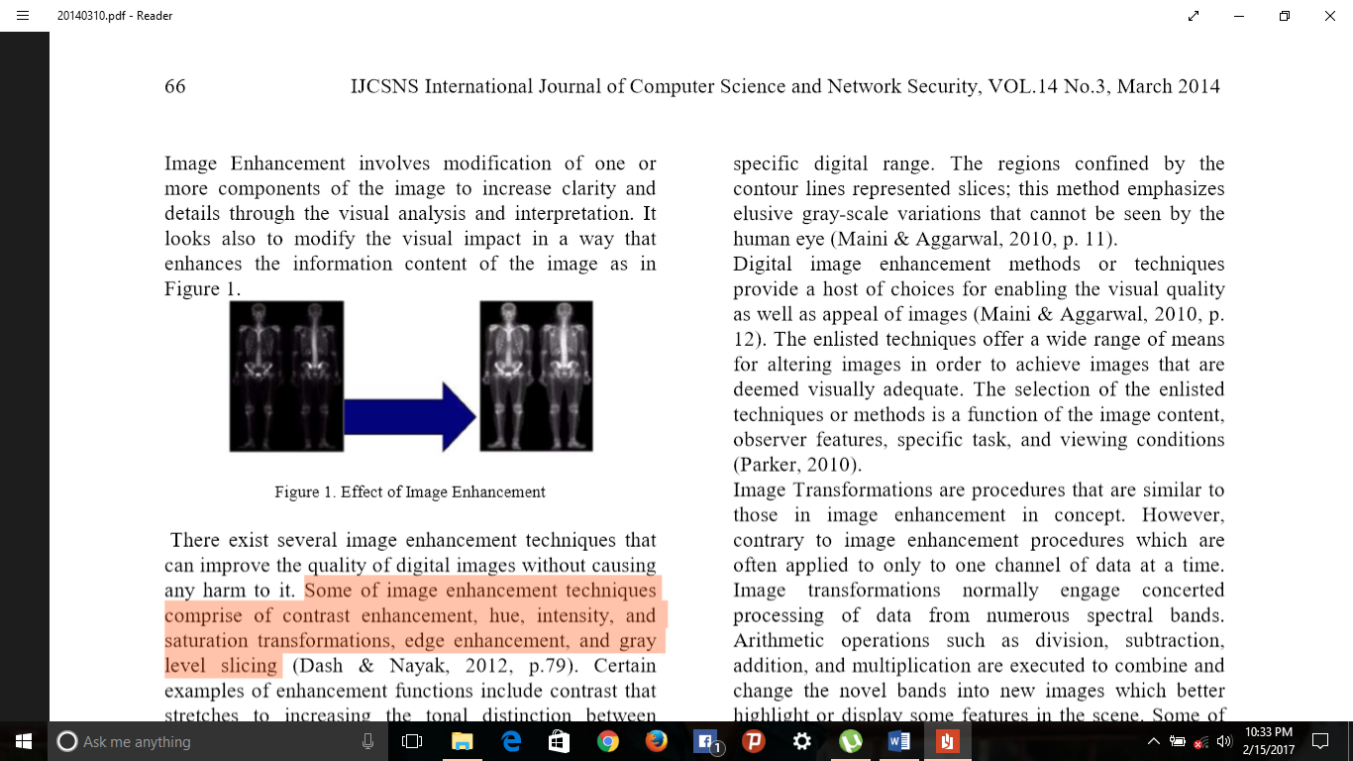

Some of image enhancement techniques include hue, intensity, and saturation transformations, contrast enhancement, and gray level slicing.[4]

**Image Transformations** are functions that are identical to those in image enhancement conceptually. However, in contrast to image enhancement functions which are often applied to only one data channel at a time. Image transformations generally engage concerted data processing from numerous spectral bands [4]. Arithmetic operations like addition, multiplication, division and subtraction are executed to combine and change the bands into new images which highlight some features in the scene. Some different methods include band or spectral rationing and principal components analysis which is often deployed more efficiently to represent the information in a multi-channel imagery.

**Image classification and analysis procedures** are adopted to digitally identify pixels in data. Classification is often performed on multi-channel datasets. This process assigns each image and pixel to an appropriate theme or class

that is based on statistical features of pixels of brightness value. There are various approaches for digital classification.

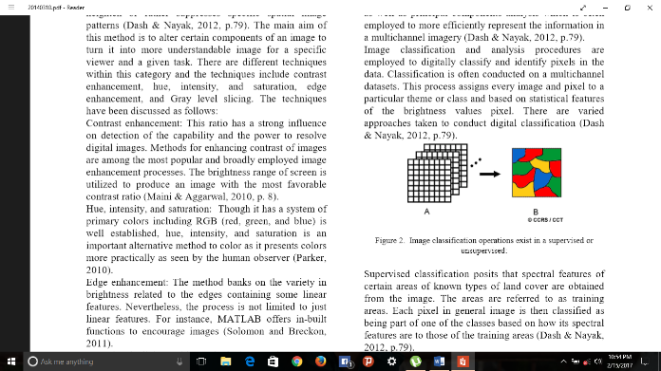

Figure 2: Image classification operations in supervised and unsupervised classifications.

Supervised classification suggests that spectral features of determinate areas of land cover are obtained from image. The areas are known as training areas. Each pixel in the image is then identified as a part of one of the classes which is based on its spectral features. [4]

In Unsupervised classification, the program on the system automatically arranges the pixels into different clusters based on their spectral features. Every cluster is assigned a land cover by the analyst. Every class of land cover is called as theme and its classification product is called as thematic map. [4]

In image processing and **Pattern recognition**, there is another technique which is known as feature extraction. It is a special dimensional reduction form. **Feature extraction** is an image processing technique also known as dimensionality reduction. It is defined as a method of converting input data into a set of features [10]. This technique helps in mining appropriate information from input data to perform desired tasks by employing this reduced form rather than the full size input.

Feature extraction is a procedure via which a combination of variables can be formed to solve

problems regarding data insufficiency [2]. Feature extraction is broadly applied in the area of Optical Character Recognition (OCR). Feature extraction has several techniques which are described below:

**Edge detection**: Edge detection is a method of locating sharp discontinuities in an image. The discontinuities in digital images are unexpected changes in the pixel intensity of the image which differentiate the border of objects in an image. [7]

**Morphological thinning**: Thinning is morphological image processing procedure which decreases the binary valued image areas to lines that are near to the center skeletons of the areas [5]. Basically, for each image area, the result lines of the thinning operation are required to be connected. This helps in identifying topology and shape in the original image. Morphological thinning is used in the image preprocessing stage to assist higher degree analysis and acknowledgement for applications such as OCR, diagram understanding, fingerprint analysis, and feature detection.

**Hough Transform**: Hough transform is a feature extraction method used in digital image processing. This technique focuses at finding imperfect instances of objects included in a specific category of shapes by a voting procedure. Hough transform highlights on the recognizing lines in an image and identifying positions of random shapes, generally circles and ellipses [8].

**Optical Character Recognition (OCR)**

The main goal of OCR is classification of optical patterns related to alphanumeric or other characters. OCR process involves several steps including classification, segmentation, and feature extraction. Each step in itself is a field, and is described within the MATLAB OCR implementation. It is a branch of computer science which involves reading text from a paper and then interpreting the images into a computer controlled form. An OCR system lets an individual to take a magazine or book, feeding it into an electronic computer, and then updating the file via a word processor.

**Methodology of OCR**

There are several steps for OCR and they can be summarized by Image Acquisition, Preprocessing and Feature Extraction.

**Image Acquisition**

In this step, the recognition system acquires a scanned image as input. The image needs to have a specific format such as BMP, JPEG and many others. The image is acquired through a digital camera, scanner, or any other desirable digital input device.

**Pre-Processing**

It is a sequence of operations applied on scanned input image. It basically enhances the image so that it becomes suitable for segmentation. The function of preprocessing is extracting the interesting pattern from the scope. In general, normalization, noise smoothing, and filtering should be done in this step.

**Feature Extraction**

In this step, the characters’ features which are considered essential for classifying them at the recognition stage are obtained. It is an essential step as its optimal functioning improves the recognition rate as well as decreases misclassification. Various Techniques of Feature Extraction are:

**Line Segmentation**

When the image matrix is ready for processing, every line of the image is separated. This is done with the help of a crosswise projection profile technique. The image is removed horizontally through a computer program in order to get the starting and ending black pixels in a particular line. The region between the obtained pixels denotes the line that holds single or more characters. The same technique is used to scan the complete image and each known line is saved in a short-term array for more processing [1]. Before performing line segmentation, borders of the image are removed such that only image text can be processed [12]. This reduces the image size and therefore enhances the process speed.

**Character segmentation**

Character segmentation is another technique of feature extraction which is used to isolate or segment the characters from digital images. After line segmentation, characters are isolated and detected by scanning each array vertically. [1] The starting and the ending black pixels which are vertically detected are referred to as character borders. There is a probability of presence of a white region which can be above or below or both to the character, segregating the tallest character as its height is similar to that of the line [11]. Accordingly, another scan is performed horizontally to detect the lower and the upper end of the character and confiscate the region which consists of character pixels only, as the edges of each character box are required for recognition purpose.

**Character Recognition**

After extracting every character individually from the image text, now each character is recognized and then displayed [6]. Though there are several methods available for recognition of characters including fuzzy logic or neural network, and online recognition but correlation coefficients method is less decomposable and more regulated as it requires just a database for linking images [3]. The accuracy of this method is based on the type of built database.

**Future Scope**

Future enhancements of this paper include use of a dictionary of words to correct the output. Implementing the use of dictionary words may refine the performance of the OCR system. One can also implement this process for classifying hand- written text. Segmentation or Segregation of characters in hand written documents is very complex and difficult as compared to printed files. Multifactorial Fuzzy System can be used for separating the characters in hand written documents.

**Conclusion**

Apparently, digital image processing technique is an important aspect of photography considering that technology keeps evolving. There are a host of image processing techniques that provide a wide variety in feature extraction and classification. Artificial neural networks are often considered to undertake character recognition because of their high forbearance to noise. The systems have the capability to perceive perfect results. Clearly, the feature extraction step of OCR is the most significant one. A poorly selected set of features will perceive poor partitioning rates by any neural network. At the succeeding stage of advancement, the software performs better in terms of accuracy or speed. It is almost impossible to replace the existing OCR techniques, particularly for English text. A simple minded approach for OCR using artificial neural networks has been explained above. The concept is very important in modern day photography and most industries have also employed the use of image processing such as in transport [9]. Recognition of characters helps in capturing great photographs that are visible from a great distance. Moreover, we can enhance our research to handwritten characters also which has been already mentioned in Future Scope.

**References**

[1] Almohri, H., J. S., & Alnajjar, H. (2008). A Real-time DSP-Based Optical Character Recognition System for Isolated Arabic characters.

[2] Basu, J. K., Bhattacharyya, D., & Kim, T.-h. (2010). Use of Artificial Neural Network in Pattern Recognition.

[3] Khan, K., Siddique, M., Aamir, M., & Khan, R. (2012).

[4] Dash, T., & Nayak, T. (2012). Non-Correlated Character Recognition using Artificial Neural Network.

[5] Kaur, K., & Sharma, M. (2013). A Method for Binary Image Thinning using Gradient and Watershed Algorithm.

[6] Kranthi, S., Pranathi, K., & Srisaila, A. (2011). Automatic Number Plate Recognition.

[7] Maini, R., & Aggarwal, H. (2009). Study and Comparison of Various Image Edge Detection Techniques.

[8] Maji, S., & Malik, J. (2009). Object detection using a max-margin Hough transform.

[9] Anagnostopoulos, C. N., Anagnostopoulos, I. E., Loumos, V., & Kayafas, E. (2006).

[10] Pradeep, J., Srinivasan, E., & Himavathi, S. (2011). Diagonal based xtraction for handwritten alphabets using neural network.

[11] Deodhare, D., Suri, N. R., & Amit, R. (2005). Preprocessing and Image Enhancement Algorithms for a Form-based Intelligent Character Recognition System.

[12] Felzenszwalb, P. F., & Huttenlocher, D. P. (2004). Efficient Graph-Based Image Segmentation.